CRM Dashboard-Events

Add Event: To schedule Appointments, Leads, Demos, etc., click on the Add Event button.

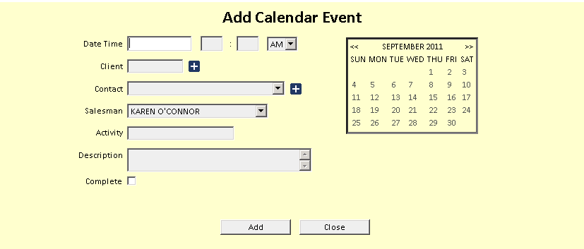

Date and Time: Enter the date or click it on the calendar to the right. Enter the time (hours/minutes) and choose am/pm from the drop-down menu.

Client: Type in the A/R Customer Number, or look up the customer by typing in a few letters of their last name or business name.

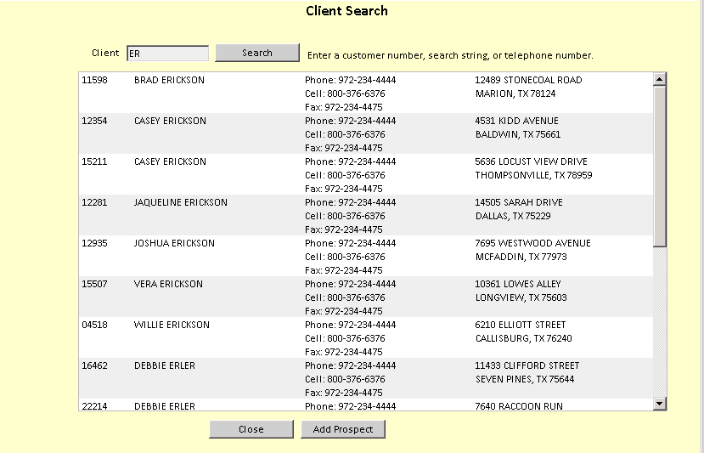

Contact: Choose a contact name from the drop-down menu. If you want to add a new contact:

- Click on the plus (+) sign.
- Fill in the fields that appear.
- Click Save.

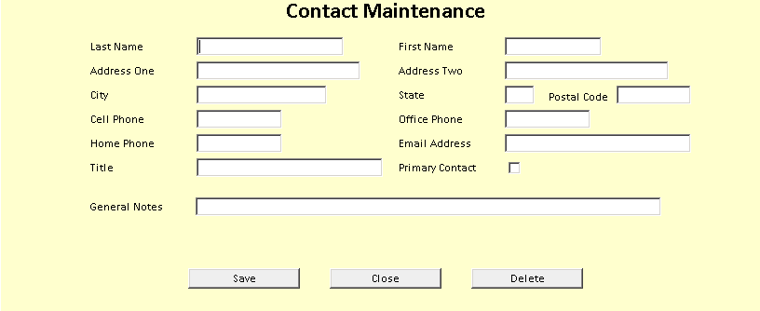

Activity: Fill in a brief description of the activity.

Description: Fill in more details of the activity as needed.

Click on “Add” to add the event to your calendar.

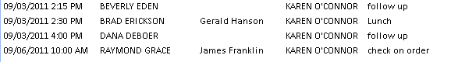

The event now appears on the Dashboard.

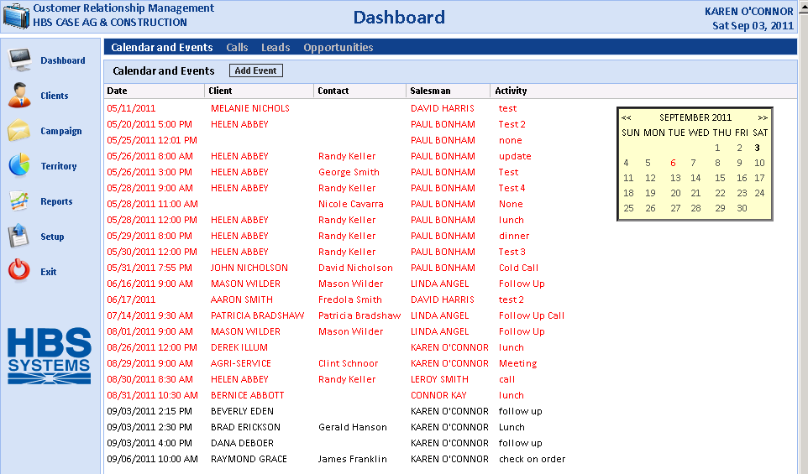

When an event date has passed and the event has NOT been marked completed, the detail lines show as red to alert you of past due activities.

By clicking on a date on the calendar, you can see that specific day's events.

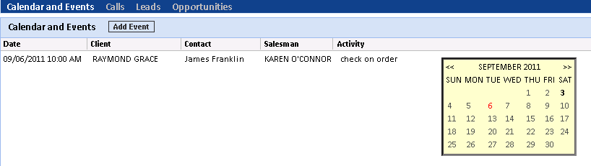

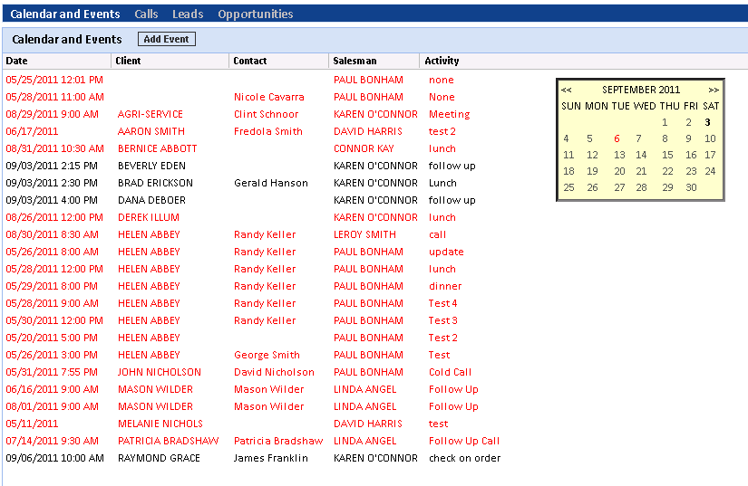

The column headings for the Calendar can be used to sort the list of events. Click the header to sort the display in that order. The column headings are:

- Date
- Client
- Contact
- Salesman
- Activity

Updating Status of Event: Click on a specific activity to update it. When the activity is finished, click on Complete. Once completed, the activity is removed from the Calendar when displaying Active events.

